CYBERSECURITY INTERNSHIP – TASK 2

Phishing Detection & Awareness System

Prepared by:
Akonaho Makhado

Organization:
Future Interns
Date:
16 April 2026

Contents
Executive Summary 3
Risk & Business Impact Assessment 4
Methodology 5
Introduction 7
1.1 Overview 7
1.2 Objectives 7
1.3 Scope of Work 7
Email Analysis & Technical Investigation 8
2.1. Phishing Sample Evidence 8
2.2 Technical Red Flags Identified 8
2.3 Header Analysis (Google Messageheader) 9
Phishing Detection & Awareness System 12
1.The “Golden Rules” of Email Security (For Employees) 12
2.Standard Operating Procedure for Suspected Threats 12
3. Technical Recommendations for the Organization 12
Comprehensive Conclusion 14
1. Synthesis of Findings 14
2. The Critical Role of Human‑Centric Defense 14
3. Strategic Roadmap for Future Security 14
4. Final Statement 14
References 16
1 Industry Frameworks & Standards 16
2 Tools & Digital Evidence 16
3 Educational Resources 16
APPENDIX A: RAW MESSAGE HEADERS 17

Executive Summary
This report presents the findings of an investigation into a targeted phishing campaign designed to harvest student and staff credentials. The attack demonstrates how adversaries exploit trusted platforms and human psychology to bypass traditional defenses.
Key Findings
- Threat Type: Credential Harvesting via Email Spoofing
- Analysis: Although the email passed technical authentication checks (SPF/DKIM: PASS), forensic review of sender details and domain inspection confirmed the message was fraudulent.
- Risk Level: CRITICAL — The attack leveraged a legitimate mail provider (Gmail) to deliver malicious links, enabling it to evade standard filtering mechanisms.
Core Recommendations
- Awareness Protocol: Implement the “Look-Hover-Report” framework to guide employees in identifying and reporting suspicious emails.
- Multi-Factor Authentication (MFA): Enforce MFA across all campus portals to prevent account compromise, even if credentials are exposed.
- Phishing Simulation Training: Conduct regular phishing simulations to build user resilience and reinforce secure behaviour.


Risk & Business Impact Assessment
1 Threat Actor Profile
The phishing attempt originates from an external actor employing social engineering and credential harvesting techniques. By leveraging a legitimate service provider (Gmail), the attacker successfully bypassed automated email filters and established a false sense of technical trust. This tactic highlights the sophistication of modern phishing campaigns, which combine technical legitimacy with psychological manipulation.

2 Business Impact
If successful, the attack could result in significant organizational consequences:
• Data Breach: Unauthorized access to sensitive student records, staff information, and intellectual property.
• Financial Loss: Increased risk of fraudulent transactions, account misuse, or ransomware deployment following credential compromise.
• Reputational Damage: Erosion of trust among students, staff, and external partners due to perceived weaknesses in institutional security controls.

3 Risk Rating
• Likelihood: High — The impersonation was convincing and capable of deceiving unsuspecting users.
• Impact: Critical — A successful compromise could lead to full account takeover and widespread exposure of sensitive data.
• Overall Risk Score: CRITICAL

Methodology

To ensure a forensic‑grade investigation, this analysis followed a structured Threat Research & Incident Response Framework. The methodology was divided into three distinct phases, each designed to capture both technical and behavioral indicators of compromise.

1 Phase I: Heuristic & Visual Analysis
The initial phase involved a manual audit of the email message body to identify social engineering techniques and deceptive elements. Key activities included:
• Sentiment Analysis: Evaluating the use of psychological triggers such as artificial urgency and fear‑based messaging.
• Source Attribution: Comparing discrepancies between the display name and the actual “Mail From” (Return‑Path) address.
• Deceptive Link Inspection: Applying “hover‑text” techniques to reveal hidden destination URLs and detect look‑alike or typosquatted domains.

2 Phase II: Technical Forensic Investigation
The second phase focused on the technical metadata of the email to verify its origin and authenticity. Activities included:
• Header Extraction: Retrieving the raw Internet Message Header to analyze the mail‑routing path.
• Authentication Verification: Using the Google Admin Toolbox (Message header Analysis) to audit cryptographic signatures:
• SPF (Sender Policy Framework): Confirming whether the sending IP address was authorized.
• DKIM (DomainKeys Identified Mail): Ensuring the message remained unaltered during transit.
• DMARC Alignment: Checking whether the technical sender aligned with the organizational domain policy.

3 Phase III: Risk Mitigation & Strategic Recommendation
The final phase synthesized evidence into actionable defensive measures. Activities included:
• Classification: Categorizing the threat based on severity and potential organizational impact.
• Defense‑in‑Depth Planning: Designing a dual‑layered protection strategy combining technical safeguards (e.g., Multi‑Factor Authentication) with human‑centric measures (e.g., awareness training and reporting protocols).

Introduction

1.1 Overview
Phishing continues to dominate as one of the most widespread and effective cyberattack vectors worldwide. Unlike purely technical exploits, phishing leverages human psychology — manipulating trust, urgency, and curiosity — to bypass defenses and compromise sensitive organizational data. This report presents a detailed analysis of a simulated phishing attempt conducted during the Future Interns Cybersecurity Internship (2026). The exercise not only highlights the mechanics of a credential-harvesting attack but also underscores the importance of vigilance and structured response in modern cybersecurity practice.

1.2 Objectives
The investigation is designed to showcase technical proficiency in threat detection and incident response, with emphasis on both technical and human factors. The objectives include:
• Technical Forensics: Examining raw email headers to validate sender authenticity using industry-standard tools such as the Google Admin Toolbox.
• Indicator Identification: Highlighting social engineering techniques including artificial urgency, domain spoofing, and deceptive URL structures.
• Risk Classification: Assessing the potential impact of the phishing attempt on organizational security posture.
• Prevention Strategy: Proposing a structured awareness program to strengthen employee resilience against future phishing campaigns.
Together, these objectives demonstrate a holistic approach — blending technical analysis with proactive defense strategies.

1.3 Scope of Work
The scope of this investigation centers on a credential-harvesting phishing email. The analysis traces the entire attack chain: from the initial delivery via a spoofed Gmail address, through the deceptive message body, to the technical breakdown of the embedded malicious link. By dissecting each stage, the report provides actionable insights into both the attacker’s methodology and the defensive measures required to mitigate such threats.

Email Analysis & Technical Investigation

2.1. Phishing Sample Evidence
The analysed phishing email was flagged due to multiple high‑risk indicators consistent with credential‑harvesting campaigns.
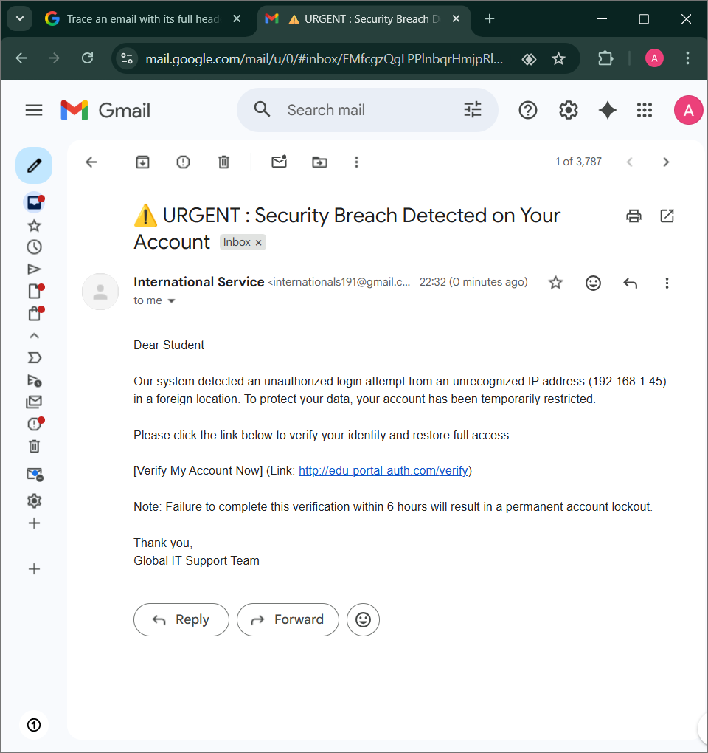

2.2 Technical Red Flags Identified
A detailed review of the message body and metadata revealed the following red flags:
• Sender Impersonation
• Display Name: International Service
• Actual Address: internationals191@gmail.com
• Finding: Legitimate institutions do not use public Gmail accounts for official security alerts.
• Malicious URL Structure
• Link: http://edu-portal-auth.com/verify
• Finding 1: Use of http indicates no SSL encryption, exposing users to interception.
• Finding 2: Domain is a typo squatted look‑alike crafted to mimic an official portal.
• Social Engineering Tactics
• Artificial Urgency: A strict 6‑hour deadline pressures users to act without critical thinking.
• Generic Greeting: “Dear Student” suggests a mass‑automated attack rather than a targeted communication.

2.3 Header Analysis (Google Messageheader)
The raw email headers were analysed using the Google Admin Toolbox to verify sender authenticity.
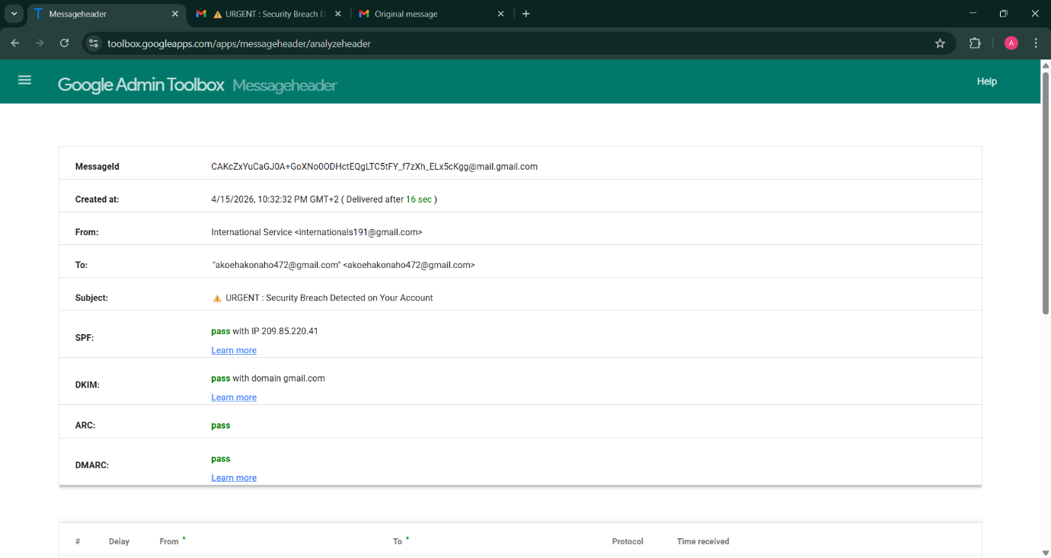
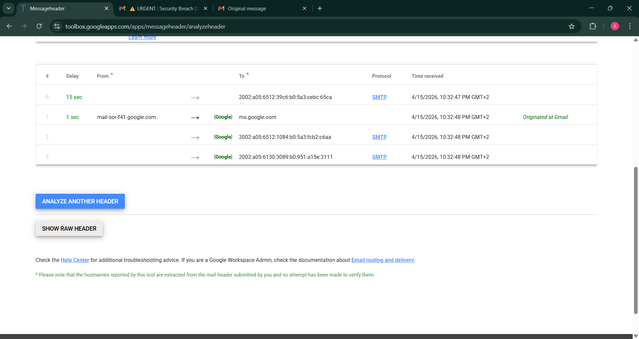
• Authentication Results: Clarifying SPF/DKIM “PASS” Results
When analysing email headers, the SPF (Sender Policy Framework) and DKIM (DomainKeys Identified Mail) checks are designed to confirm whether the email was legitimately sent through the servers it claims to use.
• In this case, the phishing email shows “PASS” for both SPF and DKIM.
• What this really means: The message did originate from Gmail’s servers, and the account used (internationals191@gmail.com) is a genuine Gmail account.
• What it does not mean: A “PASS” does not guarantee that the sender is trustworthy or that the email is legitimate. It only verifies the technical source, not the identity or intent of the sender.

The Hacker’s Technique
Attackers exploited this by creating a real Gmail account to send the phishing message. Because the account is valid, Gmail’s authentication checks pass. However, the display name “International Service” is deliberately chosen to impersonate a trusted corporate entity, misleading recipients into believing the email is official.

Analysis
It is essential to highlight in the report that:
• Server legitimacy ≠ sender legitimacy. The email technically came from Gmail, but the sender identity is fraudulent.
• This distinction demonstrates how attackers can bypass basic authentication checks by using real accounts, while still engaging in impersonation and social engineering.
• Therefore, organizations must look beyond SPF/DKIM results and evaluate contextual indicators such as suspicious domains, unusual urgency, and generic greetings.

This explanation makes the “PASS” results understandable to both technical and non‑technical readers, while reinforcing the business lesson: authentication checks are necessary but not sufficient — human awareness and layered defenses are critical.

3. Risk Classification
Category | Details
Threat Type | Credential Harvesting / Phishing
Risk Level | CRITICAL
Impact | Potential unauthorized access to student portals and sensitive data.

Phishing Detection & Awareness System

1.The “Golden Rules” of Email Security (For Employees)

To strengthen resilience against phishing, employees are trained to follow the “Look, Hover, Report” framework:
• Look at the Sender: Always verify the actual email address, not just the display name. As demonstrated in our analysis, a “PASS” result from Gmail’s servers only confirms the email came from Gmail — it does not validate the sender’s corporate identity.
• Hover Over Links: Before clicking, hover over buttons or hyperlinks to reveal the true destination. Any link using http or a suspicious look‑alike domain (e.g., edu-portal-auth.com) must be treated as a potential threat.
• Identify Emotional Triggers: Be cautious of emails that create urgency (e.g., “6 hours left”) or threaten account lockouts. These tactics are designed to override rational decision‑making.

2.Standard Operating Procedure for Suspected Threats

When a suspicious email is identified, employees must adhere to the following protocol:
1. Zero Interaction: Do not click links, download attachments, or reply to the sender.
2. Internal Reporting: Use the “Report Phishing” button in the email client or forward the email as an attachment to soc@futureinterns.com.
3. Containment: After reporting, delete the email from both the inbox and the “Deleted Items” folder to prevent accidental interaction.

3. Technical Recommendations for the Organization

While employee awareness is the first line of defense, technical safeguards provide critical reinforcement:
• Multi‑Factor Authentication (MFA): Enforce MFA across all accounts. Even if credentials are compromised, MFA significantly reduces the risk of unauthorized access.
• Advanced Threat Protection (ATP): Deploy email filtering solutions that rewrite URLs and analyse attachments in a sandbox environment to detect malicious content before it reaches users.
• DMARC Enforcement: Move toward a strict “Reject” policy for the organization’s domain. This prevents external actors from spoofing the brand, even if SPF/DKIM checks appear valid.

This version balances technical precision with business readability. It clearly outlines employee responsibilities, organizational procedures, and technical safeguards in a way that executives, managers, and staff can all understand and act upon.

Comprehensive Conclusion

1. Synthesis of Findings
The investigation into the “Urgent Security Breach” phishing campaign has provided critical insights into the evolving nature of social engineering threats. Modern phishing attacks no longer rely solely on obvious technical flaws. By leveraging legitimate infrastructure such as Gmail, the threat actor achieved SPF and DKIM validation, thereby bypassing basic reputation filters. This confirms that a “Technical Pass” in email headers should never be interpreted as a guarantee of safety, but rather as a potential disguise for fraudulent intent.

2. The Critical Role of Human‑Centric Defense
While technological controls remain essential, they are insufficient in isolation. The success of this simulated attack depended on exploiting human psychology—specifically, the manipulation of urgency and fear. This analysis reinforces the principle that the “Human Firewall” is the most vital layer of defense. Without employee awareness of look‑alike domains, generic greetings, and suspicious triggers, even advanced security software can be rendered ineffective.

3. Strategic Roadmap for Future Security
To transition from a reactive to a proactive security posture, the organization must adopt a Zero‑Trust mindset regarding external communications. The proposed Awareness System—anchored by the Look‑Hover‑Report framework—provides a foundational step toward this goal. However, security is a continuous process, not a fixed destination. Sustained resilience requires:
• Ongoing vigilance and user education.
• Technical enforcement of Multi‑Factor Authentication (MFA).
• Regular phishing simulations to reinforce secure behavior and test organizational readiness.

4. Final Statement
In conclusion, this project has demonstrated a complete end‑to‑end forensic and defensive cycle. By identifying, analyzing, and documenting the phishing threat, the organization has not only neutralized a specific risk but also established a blueprint for institutional safety. The findings underscore the necessity of combining deep technical header analysis with strong situational awareness to safeguard the digital integrity of the institution.

References

1 Industry Frameworks & Standards
- NIST Cybersecurity Framework (CSF) – Identify, Protect, Detect, Respond, Recover.
Available at: https://www.nist.gov/cyberframework
- MITRE ATT&CK Framework – Technique T1566: Phishing.
Available at: https://attack.mitre.org/techniques/T1566/
- IETF (Internet Engineering Task Force) – RFC 7208 (Sender Policy Framework) & RFC 6376 (DomainKeys Identified Mail).
Available at: https://www.ietf.org/

2 Tools & Digital Evidence
- Google Admin Toolbox – Messageheader Analysis Tool: Utilized for metadata verification and SPF/DKIM/DMARC alignment checks.
Available at: https://toolbox.googleapps.com/apps/messageheader/
- Gmail Forensic Header Export: Raw header data retrieved from Google Mail servers on April 16, 2026, for the purpose of simulated threat analysis.

3 Educational Resources
- Eduvos IT Systems Curriculum (2026) – Referenced for hardware maintenance and foundational networking troubleshooting protocols (A+ Practical Portfolio & Cisco Networking Foundations).
- Cisco Networking Academy – Introduction to cybersecurity
- Available at: https://www.netacad.com/

APPENDIX A: RAW MESSAGE HEADERS

The following metadata was extracted from the suspicious email for forensic analysis and technical verification.

Delivered-To: akoehakonaho472@gmail.com
Received: by 2002:a05:6130:3089:b0:951:a15e:3111 with SMTP id fh9csp700841uab;
Wed, 15 Apr 2026 13:32:48 -0700 (PDT)
X-Received: by 2002:a05:6512:1084:b0:5a3:fcb2:c6aa with SMTP id 2adb3069b0e04-5a3fcb2c848mr5326767e87.13.1776285168468;
Wed, 15 Apr 2026 13:32:48 -0700 (PDT)
ARC-Seal: i=2; a=rsa-sha256; t=1776285168; cv=pass;
d=google.com; s=arc-20240605;
b=Awn6DNYurVPZEJgPx/fFtpSTCUvt2mib0Zclc1ISLJ6czv+9zjYa4u7JA0Y/Ud8TAQ
rrxibIBjUNyHCSG6w+A1KuJlUD5gbM289xJjJk9vBG8YcUbRfLPZlmrAHe0T7YvL1xgM
SSr7LZ5mHgzCvFeNuya961SwmIsH2QG9Uy57MgEMya0YhOPXyAtd8zjX2/W+gzLm252z
QymGQ7ND7nPR3XH2plKLpzJaqnTvr2TrHsXTQoeAnXJuyuOSHmroZNbsZJWsR5AFlF8J
dep06ijIt6ScVJxtnPsYjc+mR52Z0Ps3P86bQu48CxRxHnm3GpFKBvqaf5dF3T+QW6IW
bELQ==
ARC-Message-Signature: i=2; a=rsa-sha256; c=relaxed/relaxed; d=google.com; s=arc-20240605;
h=to:subject:message-id:date:from:mime-version:dkim-signature;
bh=5PYRh+s/FWXOY0vFtOXOUWyFtfJM0vTVaMgqBHklRuA=;
fh=t9th/Q6Bw4IJiItU4PnYIAh5z7pjmT0bEcAgMVVlFbI=;
b=U0owYmW75Lh2xVhCXh2R0QAqC3/REKNZMONFgegRxLSudYy4LzG1YxAO8DCnk3gVxF
+/Mwo2csZKYMfx0cp+t99ctMAxKgI74IE5JPGMCvLb/RoWO63vWIC3xqiW43BReUC+nw
IrxYZiularyqSqatBD+NBa6gy7W5+GibZjKGzRj3D/XBliP8XWRafHRGGZGzuWsSVSdC
tDkUtl8NrybxZ9LT/82R/7UVEZeQPf0Tt6sFf77scx8uFX+XurYP/pk67/p61EkI0Duy
R+7wkx+HVw3Fk1Wu9ct3lwE40rj8rjwTacs2nUB7NQE79sTFucAqtZj1WUi1crnLULHe
IOCw==;
dara=google.com
ARC-Authentication-Results: i=2; mx.google.com;
dkim=pass header.i=@gmail.com header.s=20251104 header.b=Sl6bhMWF;
arc=pass (i=1);
spf=pass (google.com: domain of internationals191@gmail.com designates 209.85.220.41 as permitted sender) smtp.mailfrom=internationals191@gmail.com;
dmarc=pass (p=NONE sp=QUARANTINE dis=NONE) header.from=gmail.com;
dara=pass header.i=@gmail.com
Return-Path: <internationals191@gmail.com>
Received: from mail-sor-f41.google.com (mail-sor-f41.google.com. [209.85.220.41])
by mx.google.com with SMTPS id 2adb3069b0e04-5a40a3184d3sor434108e87.18.2026.04.15.13.32.48
for <akoehakonaho472@gmail.com>
(Google Transport Security);
Wed, 15 Apr 2026 13:32:48 -0700 (PDT)
Received-SPF: pass (google.com: domain of internationals191@gmail.com designates 209.85.220.41 as permitted sender) client-ip=209.85.220.41;
Authentication-Results: mx.google.com;
dkim=pass header.i=@gmail.com header.s=20251104 header.b=Sl6bhMWF;
arc=pass (i=1);
spf=pass (google.com: domain of internationals191@gmail.com designates 209.85.220.41 as permitted sender) smtp.mailfrom=internationals191@gmail.com;
dmarc=pass (p=NONE sp=QUARANTINE dis=NONE) header.from=gmail.com;
dara=pass header.i=@gmail.com
ARC-Seal: i=1; a=rsa-sha256; t=1776285167; cv=none;
d=google.com; s=arc-20240605;
b=FarSIa22HV1/8GfX/wLW8FNiQaIHcc/eZ/2VXzst5yHhIjBoMz3BE9Bc34qfqotdDu
yzrMUuK/NuaBqrvnv+ROqhfl4jchO2M4V2VqYBzQOsbds8PLVA/T8IpfM7Ued55py94k
5NCHdtYPZ+OragNO3tsYJOp3ndy+fz4kvTbL/m4zaIguY9JOFIWtTpeXl3bZNC0w51Qe
GG5SYwEv92Tcz3ghsptoustP0BbuIidfiaA/YIcUyfP0TWAQaC2dce4sM/Vh5HVYjfWs
2XcA7s9mjEFu5YPsmm+SDaqdIdxbF7xmpOYco59/xCOfjjdd4xFZc9t8PB2ZepfktnjP
WPuA==
ARC-Message-Signature: i=1; a=rsa-sha256; c=relaxed/relaxed; d=google.com; s=arc-20240605;
h=to:subject:message-id:date:from:mime-version:dkim-signature;
bh=5PYRh+s/FWXOY0vFtOXOUWyFtfJM0vTVaMgqBHklRuA=;
fh=t9th/Q6Bw4IJiItU4PnYIAh5z7pjmT0bEcAgMVVlFbI=;
b=aNx5ZuM5nS4IU/fk3uCRTNhOJqxZ+u3kZZwaiTc+4lEhgYaugv1dTg/YmmDkSA7G40
0xtOK0Gcv+agKmd6vXfeRMps+lyalsYVnFCATXGkyg6FFdjwd3UAbeDYN9LsEpPBSFLw
o/BbgZv/vBFMa3UC9CpkBp0QxslzuvfFe8ERA3NS87AN2otQjDeG25GPLWx9VLa2Fwlp
PvDaCRRYpZkEggmUDyhDP5kuJgMrLcWyKNTl7ZhUk5Kyh+rXByUjXeNl8WqwadbBxIKC
VFJmgkDj8siB8RvdqtV3T1xMoQ/iHZiAK4gOa3TpXUgf4Ds2GmIFzjUI7TPEO/I2CZ/Y
qZiQ==;
dara=google.com
ARC-Authentication-Results: i=1; mx.google.com; arc=none
DKIM-Signature: v=1; a=rsa-sha256; c=relaxed/relaxed;
d=gmail.com; s=20251104; t=1776285167; x=1776889967; dara=google.com;
h=to:subject:message-id:date:from:mime-version:from:to:cc:subject
:date:message-id:reply-to;
bh=5PYRh+s/FWXOY0vFtOXOUWyFtfJM0vTVaMgqBHklRuA=;
b=Sl6bhMWFr3ieQncSYb7IHViX3gkgV6NNaHHVbBvztzoesxKX4yGZygrG1cXAkfT8i0
EBi6JB9+K9JT0TMNhJCaG+IzdiANcRyxBu3OdboPVm9jd94u+86xsPvOT0O5vwal/nkV
e44U+JdkU/0DM54+KTtak+tRdkKSFzdH3PodPy5f1arnLLcAKBdNbGPixfmRPyJZebrl
0GGyAXgF2l6y0G8dZWgC6/TienqcoEAJp0AL6XkHDuElof7nSUgRX9G6BmPKMGCguthw
8N0tQJ9cjRFTlGfGXfH5k5TJg7JUI/oybufZlmgepcwxJjq2foCGa/WqZb4YSZTm9onD
Ij8A==
X-Google-DKIM-Signature: v=1; a=rsa-sha256; c=relaxed/relaxed;
d=1e100.net; s=20251104; t=1776285167; x=1776889967;
h=to:subject:message-id:date:from:mime-version:x-gm-gg
:x-gm-message-state:from:to:cc:subject:date:message-id:reply-to;
bh=5PYRh+s/FWXOY0vFtOXOUWyFtfJM0vTVaMgqBHklRuA=;
b=Kknpvpbg4tAr76Qf3STr1R3towdBdI4SbfhRiCGNos1B+gDPqIduA82agb3ejupOza
U1SlajhSoFuk5kEWia7ZPwofvsXFZaZoKyKs1z/sO0qo+frbIPo6bvPzO0gs2Ae19go9
quFBRzURt7rZTVjuYoVNt89evsvXJi56ALnYOWgMAExtyx7suGuFp0ZdDEe6IwQAQ2zv
tRlosAxubtPJackv/tZaEnbcXv+u5ybP3OFKyS75gw/MhwXkT1JT4/Lq8sVJUUA1FCoI
gBcItGMP9PxxF8jVrkO6K4aGH//DajwzxZOQ9j8gqgnf64ZQYChyY8pEAYHwPw8p8MWk
e0bQ==
X-Gm-Message-State: AOJu0Yw5WCFyDqCW3NYSUw3X/zG7qUPKB2hZAZZVDtWL9rNM03jHWjch aEDhgbt+9y7vEWAJSzujE4RLkQWW6ZuQxWssr5s8toeGTdYh+RJ7b61/SENt5U3YKzjGp224Ny4 vsfrv/jWaKINCYRLo3XPuPd3RUicP4Olc9w==
X-Gm-Gg: AeBDietR64yeZ0Ai7UhGtddurvJnGWJAncoBZ1nuA/LTwNZaBOZ/6ZXM4v8KA+jZdVr B15Rm9uhM9Smd3HQnb8Imb0lEKp6clvLajgj+k7X3G2mRkxOlmi3qAkhROqEffFEAThLpvTftjt hJxqnRy8ohPjn04udIPxbikVJhUzj2PCyO+xm18steXFt/SnDmenJy2+LKR5LhZYR5lg1bK7p5W dlKLmcOEZVtFYbMwBHh8vkPxm+72o5P6DrUihx/q0MY9ieKc7J+IsiTh3LXX13q6eO/3OPqQv7Z XUypTgk/
X-Received: by 2002:a05:6512:39c6:b0:5a3:cebc:65ca with SMTP id 2adb3069b0e04-5a3ef6fe0c8mr7784697e87.7.1776285167131; Wed, 15 Apr 2026 13:32:47 -0700 (PDT)
MIME-Version: 1.0
From: International Service <internationals191@gmail.com>
Date: Wed, 15 Apr 2026 22:32:32 +0200
X-Gm-Features: AQROBzAKmf4A2DaVwSbbmGt4I1y36xVZUyzmXuzmB5C-IJbhWbEphB0OKrh8yZg
Message-ID: <CAKcZxYuCaGJ0A+GoXNo0ODHctEQgLTC5tFY_f7zXh_ELx5cKgg@mail.gmail.com>
Subject: ⚠️ URGENT : Security Breach Detected on Your Account
To: "akoehakonaho472@gmail.com" <akoehakonaho472@gmail.com>
Content-Type: multipart/alternative; boundary="0000000000006820c9064f859e9b"

--0000000000006820c9064f859e9b
Content-Type: text/plain; charset="UTF-8"

Dear Student

Our system detected an unauthorized login attempt from an unrecognized IP
address (192.168.1.45) in a foreign location. To protect your data, your
account has been temporarily restricted.

Please click the link below to verify your identity and restore full access:

[Verify My Account Now] (Link: http://edu-portal-auth.com/verify)

Note: Failure to complete this verification within 6 hours will result in a
permanent account lockout.

Thank you,
Global IT Support Team

--0000000000006820c9064f859e9b
Content-Type: text/html; charset="UTF-8"
Content-Transfer-Encoding: quoted-printable

<div dir=3D"auto"><div dir=3D"auto"><br></div><div dir=3D"auto">Dear Studen=
t</div><div dir=3D"auto"><br></div><div dir=3D"auto">Our system detected an=
unauthorized login attempt from an unrecognized IP address (192.168.1.45) =
in a foreign location. To protect your data, your account has been temporar=
ily restricted.</div><div dir=3D"auto"><br></div><div dir=3D"auto">Please c=
lick the link below to verify your identity and restore full access:</div><=
div dir=3D"auto"><br></div><div dir=3D"auto">[Verify My Account Now] (Link:=
<a href=3D"http://edu-portal-auth.com/verify">http://edu-portal-auth.com/v=
erify</a>)</div><div dir=3D"auto"><br></div><div dir=3D"auto">Note: Failure=
to complete this verification within 6 hours will result in a permanent ac=
count lockout.</div><div dir=3D"auto"><br></div><div dir=3D"auto">Thank you=
,</div><div dir=3D"auto">Global IT Support Team</div></div>

--0000000000006820c9064f859e9b--

The following data represents the unedited metadata and routing information extracted from the suspicious email for forensic verification.

